INTER-DEPARTMENTAL PROJECT-II REPORT

# “NUMBER PLATE DETECTION NEAR PARKING”

**Submitted**

by

|  |  |
| --- | --- |
| B.Deepthi  201FA04140 | G.Durga Susmitha  201FA04147 |
| Lavanya  201FA04172 | |

**Under the guidance of**

***Mr.Sk.Sikindhar,Asst.professor,***

***Dept of CSE***



**DEPARTMENT OF COMPUTER SCIENCE & ENGINEERING**

**VIGNAN'S FOUNDATION FOR SCIENCE, TECHNOLOGY AND RESEARCH Deemed to be UNIVERSITY**

**Vadlamudi, Guntur.**

**VIGNAN’S FOUNDATION FOR SCIENCE, TECHNOLOGY AND RESEARCH**

**Deemed to be UNIVERSITY**

VADLAMUDI, GUNTUR DIST, ANDHRA PRADESH, INDIA, PIN-522 213



**CERTIFICATE**

This is to certify that the Inter-Departmental Project-II entitled **“Number Plate Detection Near Parking”** that is being submitted by **B.Deepthi (201FA04140), G.Durga Susmitha (201FA04147), Lavanya(201FA041)** for partial fulfillment of Inter-Departmental Project-II is a bonafide work carried out under the supervision of ***Mr.Sk.Sikindhar,Asst.professor,Dept of CSE*** from Department of Computer Science & Engineering.

***Mr.Sk.Sikindhar, Dr.K.V.Krishna Kishore***

***Asst.professor,Dept of CSE* Professor & HOD-CSE**

Internal Examiner External Examiner

**VIGNAN’S FOUNDATION FOR SCIENCE, TECHNOLOGY AND RESEARCH**

**Deemed to be UNIVERSITY**

VADLAMUDI, GUNTUR DIST, ANDHRA PRADESH, INDIA, PIN-522 213



**DECLARATION**

We hereby declare that the Inter-Departmental Project-II entitled **“Number Plate Detection Near Parking”** is being submitted by **B.Deepthi (201FA04140), G.Durga Susmitha (201FA04147), Lavanya(201FA04172)** in partial fulfillment of Inter-Departmental Projects-II course work. This is our original work, and this project has not formed the basis for the award of any degree. We have worked under the supervision of ***Mr.Sk.Sikindhar,Asst.professor,Dept of CSE*** from Department of Computer Science & Engineering.

By

201FA04140

201FA04147

201FA04172

Date:

**TABLE OF CONTENTS**

|  |  |
| --- | --- |
| Abstract |  |
| 1. Introduction | 1 |
| 1. Problem statement | 1 |
| 1. Scope | 2 |
| 1. Challenges in number plate detection | 2 |
| 1. Steps followed:    1. Importing Libraries    2. Resizing Image    3. RGB to Gray Scale    4. Reducing Noise    5. Detecting Edges    6. Detecting Contours    7. Sorting the Contours    8. Extracting text | 3-6 |
| 1. Requirements | 6 |
| 1. Sample Code | 7-8 |
| 1. Result | 9-12 |
| 1. Conclusion | 13 |
| 1. Future Scope | 14 |
| 1. References | 15 |

**ABSTRACT**

Automatic Number Plate Recognition System is an essential stage for the automation of traffic system. Use of vehicles is getting increased in today’s era that is why traffic control is being tough. It is hard to store and maintain the record of vehicles manually . Automatic Number Plate Recognition System can be used for better Control of vehicles and for store and maintain the record of vehicles automatically. Automatic Number Plate Recognition System is the identification system of vehicles. It is an image processing technology used to identify the vehicles only by their license plates. Automatic Number Plate Recognition ANPR plays am major role in management of parking areas, and surveillance of illegally parked vehicles. Since every vehicle has a unique number plate so it can be identified by its number plate. The classification is utilized for the electronic to l-collection system (ETC) and to display available parking space to vehicles. The identification is also employed for managing parking facilities, monitoring and analysis of traveling time, and security systems such as observation of stolen vehicles and monitoring of unauthorized vehicles entering private areas.

**1.INTRODECTION**

Number plate recognition is realized by acquiring images of either the front or the rear of vehicles with cameras and then by image processing to identify license plates. It consist of three main stages. First one is Number Plate Identification & Localization in this segment the visual of the scene is improved with is image processing. Second is Character Segmentation in which characters segmented from the detected number plate for retaining the useful information to the system so that further processing can take place. Third is OCR Optical Character Recognition in which text is transferred into encoded text information.

**2.PROBLEM STATEMENT**

Automatic Number Plate Recognition System is the identification system of vehicles. It is an image processing technology used to identify the vehicles only by their license plates. Automatic Number Plate Recognition ANPR plays am major role in management of parking areas, and surveillance of illegally parked vehicles. Since every vehicle has a unique number plate so it can be identified by its number plate. The classification is utilized for the electronic to l-collection system (ETC) and to display available parking spaces to vehicles. The identification is also employed for managing parking facilities, monitoring and analysis of traveling time, and security systems such as observation of stolen vehicles and monitoring of unauthorized vehicles entering private areas

**3.SCOPE**

The aim of the Automatic Number plate recognition (ANPR) is record keeping as record keeping is the very difficult job to do manually. In this system our most focus is on reducing the manual work in opening and closing of gate.

The main goal of this work is to design and implement efficient and novel architectures for automatic number plate recognition (ANPR) system, which operates in high definition (HD) and in real time. In addition, a separate ANPR algorithm is developed and optimized, by taking advantage of technical features of digital image processing algorithms.

# 4.Challenges In Number Plate Recognition

Any emerging technology faces difficulties. There are still various problems with automatic number plate recognition systems. The most common challenge they face is the non-uniformity of license plate number models for different cities and countries.Their length may also vary.That’s why the ANPR software must be customized to the specific place it’s being used in.Developers now work on easily customized software for number recognition that provides high quality footage and extreme accuracy. This would make the ANPR application suitable for every country in the world. Most of the challenges that first came up with the idea of automatic ANPR are now overcome and the only thing that should be taken care of is the protection of the collected data.

# Steps Following In Number Plate Detection

# 5.1. Importing Libraries

The Libraries we need here are :

* OpenCV :

OpenCV stands for open-source computer vision. It was generated to support a common infrastructure for computer vision operations and use system behaviour in financial products. It generally targets image processing, faces recognition, video capture, searching, and object disclosure.

OpenCV is created to implement various operations including recognizing and detecting faces, analyzing human tasks in videos, identifying objects, recording camera movements, tracking moving objects, and combining images to create a high-resolution image for the accurate scene.

* There are three main tasks which are defined below −

1. **Pattern recognition:** It provides multiple procedures to connect the patterns inside an image.
2. **Photo grammetry:** It can take accurate frequency from pictures.
3. **Image processing:** It is used to image direction.

* Imutils :

A series of convenience functions to make basic image processing functions such as translation, rotation, re-sizing, skeletonization, displaying Matplotlib images, sorting contours, detecting edges, and much more easier with OpenCV and both Python 2.7 and Python 3.

* pytesseract :

Pytesseract or Python-tesseract is an Optical Character Recognition (OCR) tool for Python. It will read and recognize the text in images, license plates etc. Python- tesseract is actually a wrapper class or a package for Google’s Tesseract-OCR Engine. It is also useful and regarded as a stand-alone invocation script to tesseract, as it can easily read all image types supported by the Pillow and Leptonica imaging libraries, which mainly includes –

1. jpG
2. png
3. gif
4. bmp
5. tiff etc

# 5.2. Resizing the image

**R**esizing an image is a good practice, it helps with processing the image better and also helps the machine train on smaller images faster

# 5.3. Converting Our image from RGB to Gray Scale

**N**ow before detecting the number plate we would need to do some image processing so that detection becomes easy. First of all, we would convert our image from RGB to Grayscale We can Complete this task by making use of method in opencv called cvtColor() method.

# 5.4. Reducing Noise From our Image

Apply a Bilateral filter over it in order to reduce image noise. Noise removal is an important task in image processing. In general the results of the noise removal have a strong influence on the quality of the image processing techniques.

# 5.5. Detecting the edges of the images .

By using cv2.Canny(image, lower, upper) we would detect the edges of the objects in the images. Edges help us in separating objects from another, and computers would like to do the same. With the help of the following code, the computer would be able to determine object boundaries and thus separate the object of interest.

# 5.6. Finding Contours of the image

We will be using cv2.findContours(image name, cv2.retr_list, cv2.chain_approx_simple) to do so.. Contours are basically the curves that join all the continuous points having the same intensity or color, cv2.findContours(image name, cv2.retr_list, cv2.chain_approx_simple) join a l the points along the boundary of an object, therefore using the image with edges detected is better.

# 5.7. Sorting the contours

All Contours include very small and insignificant ones as well so we would want to get rid of those and would want only the major contours. So we would loop over all the contours, and find out which contour is fit to be a license plate.

we would like to find the contour that is rectangular in shape, and we would be using the function cv2.approxPolyDP(current contour, maximum distance from contour to approximated contour True) for this, which will approximate a polygon (in our case, a rectangle).

# 5.8. Extracting Text From image

We can use pytesseract to extract the license number from the number plate. Pytesseract is an optical character recognition (OCR) tool for python. It helps in recognizing the text and digits in an image.

1. **REQUIREMENTS**

* **Software Requirements:**
* python
* opencv-python
* imutils
* pytesseract
* jupyter notebook
* Pip
* **Hardware Requirements:**
* Processor: Intel core i5 or above.
* 64-bit, quad-core, 2.5 GHz minimum per core
* Ram: 4 GB or more
* Hard disk: 10 GB of available space or more.
* Display: Dual XGA (1024 x 768) or higher resolution monitors
* Operating system: Window

1. **SAMPLE CODE**

import cv2

import imutils

import pytesseract

import numpy as np

pytesseract.pytesseract.tesseract_cmd=r"C:\ProgramFiles\TesseractOCR\tesseract.ex"

image=cv2.imread('C:\\Users\\ammua\\Downloads\\12.jpeg')

image=imutils.resize(image , width = 500)

cv2.imshow('OriginalImage',image)

cv2.waitKey(0)

gray=cv2.cvtColor(image , cv2.COLOR_BGR2GRAY)

cv2.imshow("Gray Scale Image",gray)

cv2.waitKey(0)

gray=cv2.bilateralFilter(gray , 11 , 17 , 17)

cv2.imshow("Smoother Image", gray)

cv2.waitKey(0)

edged=cv2.Canny(gray,170,200)

cv2.imshow("Canny edge",edged)

cv2.waitKey(0)

Cnts,new=cv2.findContours(edged.copy(),cv2.RETR_LIST,cv2.CHAIN_APPROX_SIMPLE)

image1=image.copy()

cv2.drawContours(image1 , cnts , -1 , (0,255,0),3)

cv2.imshow("Canny after Contouring",image1)

cv2.waitKey(0)

cnts=sorted(cnts , key=cv2.contourArea , reverse = True)[:30]

NumberPlateCount = None

image2=image.copy()

cv2.drawContours(image2 , cnts , -1 , (0,255,0),3)

cv2.imshow("TOP 30 Contours",image2)

cv2.waitKey(0)

count=0

name=1

for i in cnts:

perimeter=cv2.arcLength(i,True)

approx=cv2.approxPolyDP(i,0.02*perimeter , True)

if(len(approx)==4):

NumberPlateCount = approx

x,y,w,h=cv2.boundingRect(i)

crp_img = image[y:y+h , x:x+w]

cv2.imwrite(str(name)+ '.png',crp_img)

name += 1

break

cv2.drawContours(image,[NumberPlateCount],-1,(0,255,0),3)

cv2.imshow("Final Image",image)

cv2.waitKey(0)

crop_img_loc = '1.png'

cv2.imshow("Cropped Image", cv2.imread(crop_img_loc))

cv2.waitKey(0)

gray_scaled1 = cv2.cvtColor(cv2.imread(crop_img_loc), cv2.COLOR_BGR2GRAY)

ret,processed_img = cv2.threshold(np.array(gray_scaled1), 125, 255, cv2.THRESH_BINARY)

cv2.imshow("Number Plate",processed_img)

cv2.waitKey(0)

text = pytesseract.image_to_string(crop_img_loc)

print("Number is : ",text)

cv2.waitKey(0)

1. **RESULT**

* **Original Image:**

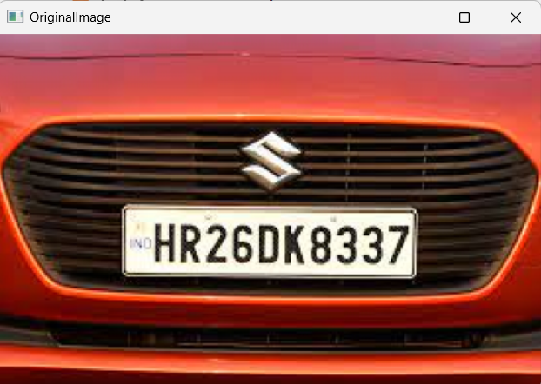

* .**Gray Scale Image:**

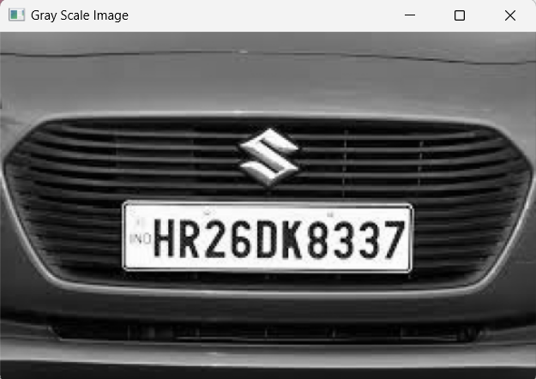

* **Smoother Image:**

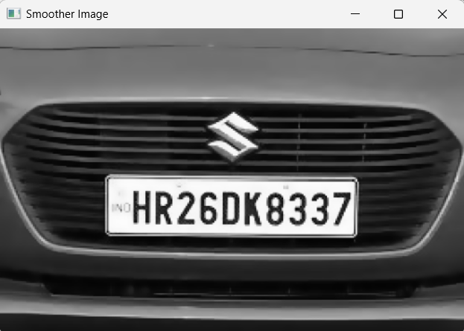

* **Canny Edge:**

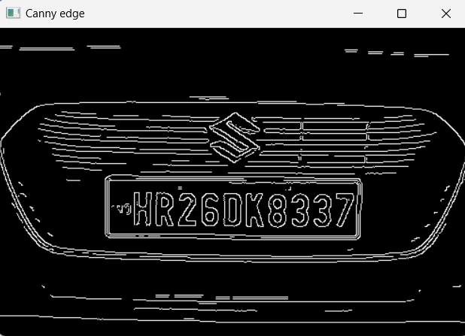

* **Canny after Contouring:**

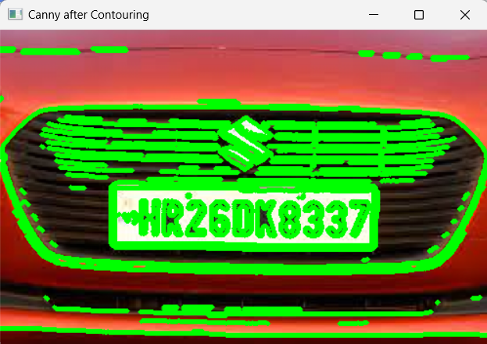

* **Top 30 Contours:**

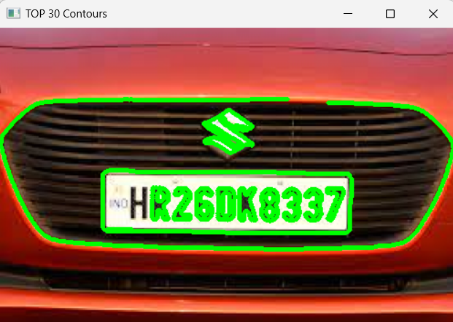

* **Final Image:**

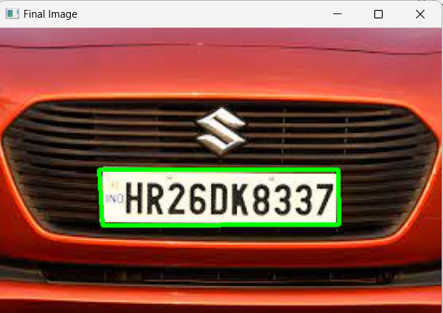

* **Cropped Image:**

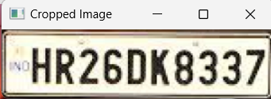

* **Number Plate:**

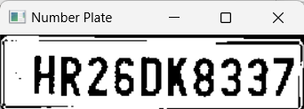

* **Text From Image:**



**9.CONCLUSION**

* In ANPR System,A image willbe taken and will be pre-processed first to reduce the noise present in that image converting RGB image into Gray Scale image which will be further converted to smoother image by reducing noise and will be finding edges and contours . By sorting the top 30 Contours identified we are finding the region of number plate and will be extracting text from the vehicle number plate .

**10.FUTURE SCOPE**

* In future, Image capturing system will insta l. Camera wi l place on door, when car will arrive camera capture picture of front of car then localize the number plate and do further recognition process. If number plate is authorized then door will open otherwise an alarm will ring.

**11.REFERENCES**

* https://ieeexplore.ieee.org/document/8748287
* https://viso.ai/computer-vision/automatic-number-plate-recognition-anpr/
* https://[www.researchgate.net/publication/332687116_NUMBER_PLATE_RECOGNIT](http://www.researchgate.net/publication/332687116_NUMBER_PLATE_RECOGNIT) ION_ SYSTEM
* https://ieeexplore.ieee.org/document/7831610